Databricks & Azure Data Lake benefits
- We can store any type of file - structured and unstructured data, machine learning models
- We have distributed storage and computing - so we never run out of memory or computational power
- Flexibility of programming - in Databricks notebooks we can execute python or scala code which gives us a lot of flexibility when building data pipelines, making calculations on a data and it allows for building machine learning models
- We can store data in a delta table format which provides for example following benefits:
  - Fast data querying - that’s because data is stored in a column oriented way
  - Time travel - we can check how table looked like before because there is information saved about what changes were made to a table
  - Efficient updating, inserting and deleting rows
  - Efficient modifying table schema - adding, modifying, deleting columns

Workspace notebooks
In a workspace we can create notebooks. In those notebooks we can write python, scala or sql code:
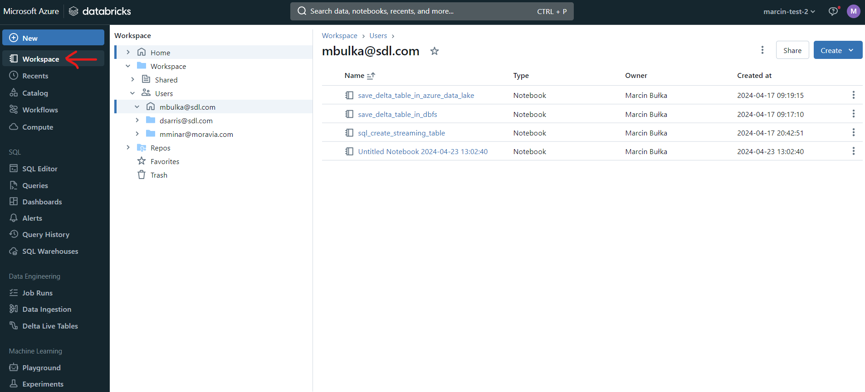

Compute
In the compute section we have our clusters of nodes (servers) which are making computations from our notebooks’ code. We can also store data and files on those clusters:
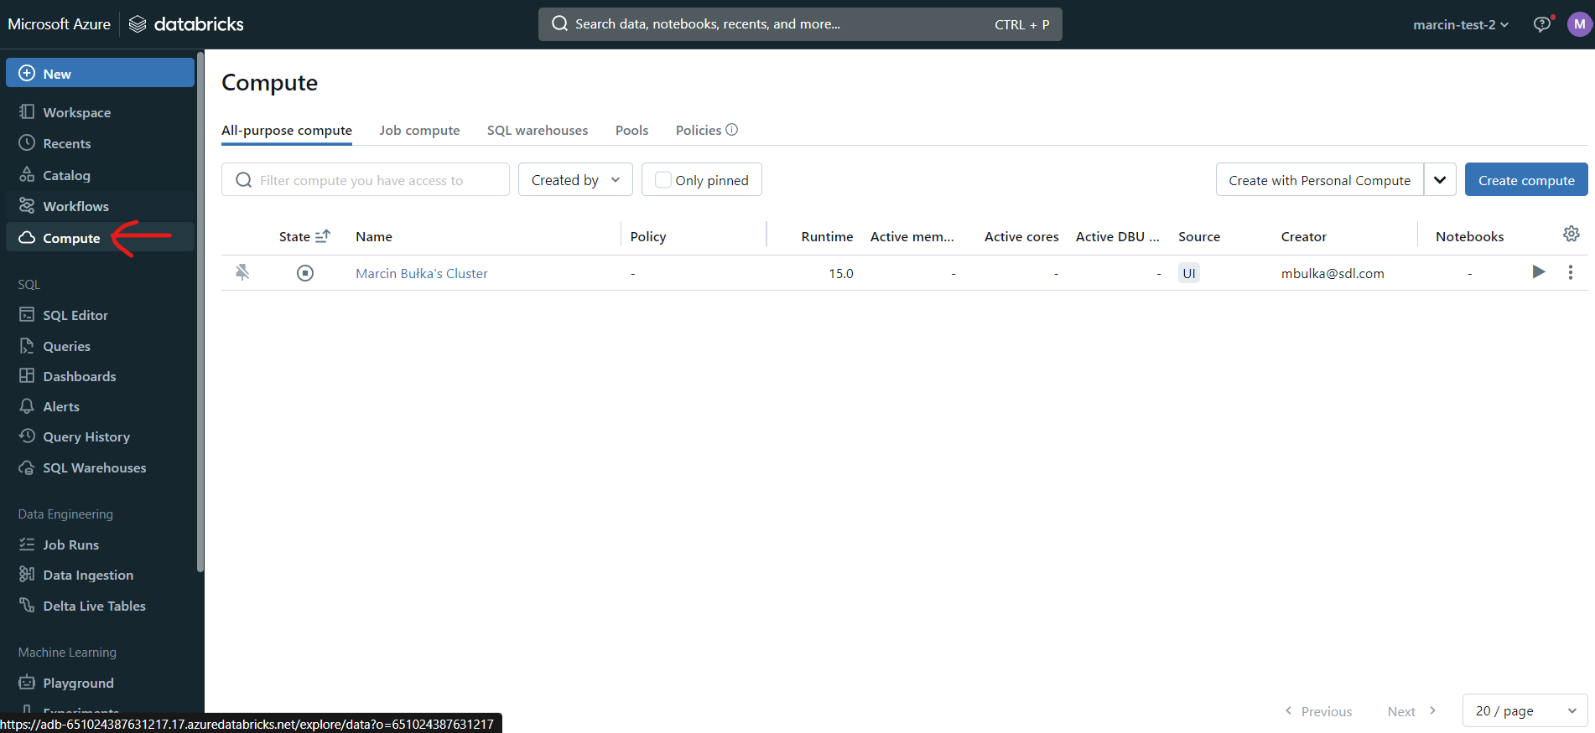

DBFS
DBFS stands for databricks file system. This file system is on cluster of nodes (servers) which are making computations from our notebooks’ code and we can save there our data and files. We can access it by using dbutils.fs commands in notebooks, for example:
- remove files from a folder: dbutils.fs.rm(folder_path, True)
- list files from a folder: dbutils.fs.ls(folder_path)

Azure Data Lake
We can keep here our files. There are so called containers:
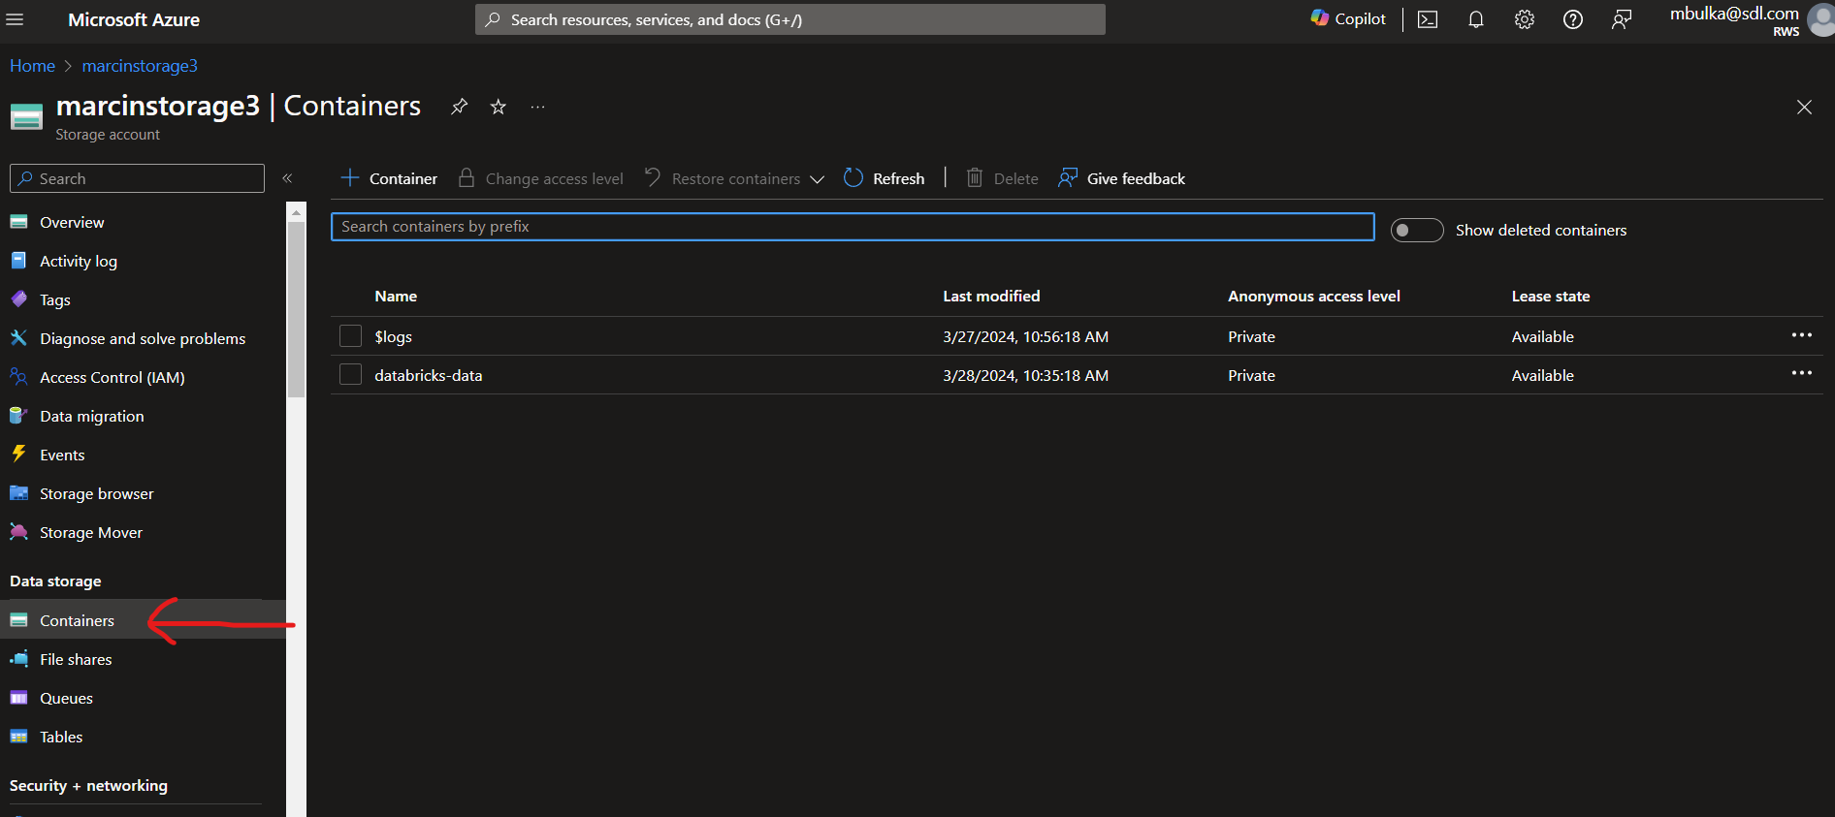
In each container we can create folders and upload files.

In order to access those files in databricks notebooks we need to write this code:
spark.conf.set(
"fs.azure.account.key.<storage account name>.dfs.core.windows.net",
"<access key to a storage account>"
)
And after that we can read data from Azure Data Lake by running for example this command:
spark.read.csv("abfss://<container name>@<storage account name>.dfs.core.windows.net/<path to csv file>")

Databricks CLI
In order to open Databricks CLI we need to click the icon in the bottom right corner:
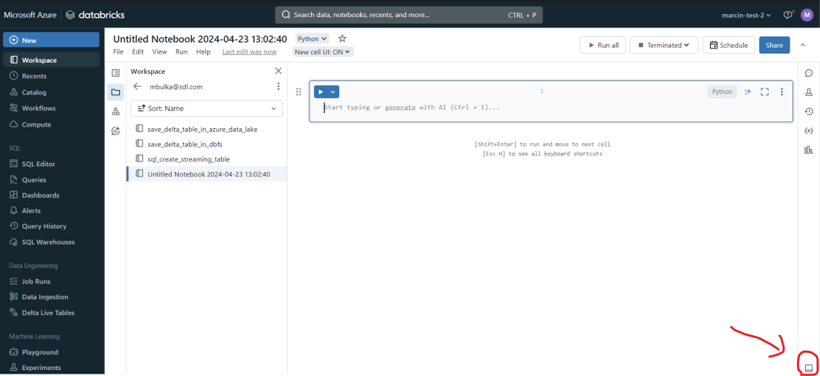
We can use Databricks CLI for example in order to create Databricks secrets.

Databricks secrets
Databricks secrets allow us to create secrets which contains json objects of the following format:
{
"scope": string,
"key": string,
"string_value": string
}

We can for example create a secret which contains credentials needed to connect to Azure Data Lake. In order to do this we need to run those commands in databricks CLI:
- databricks secrets create-scope source_databases --initial-manage-principal users
- databricks secrets put-secret --json '{
"scope": "source_databases",
"key": "<storage account name>",
"string_value": "<access key to a storage account>"
}'

After running those commands we can connect to Azure Data Lake by running this code in notebook:
spark.conf.set(
"fs.azure.account.key.marcinstorage3.dfs.core.windows.net",
dbutils.secrets.get(scope="source_databases", key="<storage account name>")
)
So the dbutils.secrets.get(scope, key) returns the ‘secret_value’ from our secret for given scope and key.

Delta tables
Delta table is a format for storing tabular data. It stores data for one table in a bunch of files (for example csv. It can be one or multiple files) in a folder.

There is also a delta_log folder which keeps transaction logs. Those logs contain information about all the changes we made to a table. It allows for example to go back in time to check how a table looked like before. It also allows for efficient modifications of a table like inserting, modifying or deleting rows or columns.

Delta tables allow for quick querying. It stores data in a column oriented way, like in sql server when you are using indexes.

How to create a delta table
In order to create a delta table we need to create a folder with parquet files which contain data and a delta_log folder in which there will be saved transaction logs.

At first we need to created a dataframe using for example this command:
df = spark.read.csv("abfss://<container name>@<storage account name>.dfs.core.windows.net/<path to csv file>")
Then we can save it in Azure Data Lake in a delta table format using this command:
df.write.format("delta")
.mode(SaveMode.Overwrite) // Choose appropriate SaveMode (Overwrite, Append, etc.)
.save("abfss://<container name>@<storage account name>.dfs.core.windows.net/<path to a folder>")
So that code will create a folder with parquet files and a delta_log folder.

Auto Loader
We can use the Auto Loader (spark.readStream() function) in order to read data incrementally from the source. New files will be processed automatically (once per defined period of time) as they arrive to a specified folder and no files will be processed twice.

This code is reading data once per 10 second from a folder containing csv files. So once per 10 sec it will check if in a given folder there are new csv files which were not processed yet. If there are such a files then this code will read data from them. The folder in which we will be looking for a new files is given by the path ‘csv_files_path’.

Then we are creating a delta table which contains data from those csv files and it will be saved in the Azure Data Lake, in the folder given by the path delta_tables_path:

streaming_df = (spark.readStream
.format("cloudFiles")
.option("cloudFiles.format", "csv")
.option("cloudFiles.schemaLocation", checkpoint_path)
.load(csv_files_path)
)

write_stream = (streaming_df.writeStream
.format("delta")
.outputMode("append")
.option("checkpointLocation", checkpoint_path)
.trigger(processingTime = '10 seconds')
.start(delta_tables_path)

- .format("cloudFiles") informs that we are loading data from the cloud
- .option("cloudFiles.schemaLocation", checkpoint_path) is defining that we will be saving info about data schema in the folder with path checkpoint_path.
- .option("checkpointLocation", checkpoint_path) defines that in the checkpoint_path there will be saved data about which files were already processed so spark can progress from where it left off in case of failure. Thanks to that files also won't be processed twice.
- We can use either .trigger(availableNow=True) in order to load data only once or .trigger(processingTime = '10 seconds') in order to start loading data every 10 seconds

Reading data using SQL
Once we saved data in a delta table format (we created folder with parquet files and delta_log folder), we can’t use sql in order to query it in a different notebook. At first we need to save additional metadata about those files in either Hive Metastore (legacy) or Unity Catalog (recommended). For that we can use sql commands:

%sql
drop table if exists delta_table;

-- create a table using data from the azure data lake. This will save table metadata in hive metastore or unity catalog
CREATE TABLE delta_table
USING DELTA
LOCATION 'abfss://<container name>@<storage account name>.dfs.core.windows.net/delta_tables/df';

-- read data from the table
SELECT * FROM delta_table

After using the ‘CREATE TABLE delta_table’ command we are creating metadata describing our table and now we can use sql in order to query that table, even in another notebook. So we need to use the ‘CREATE TABLE’ command only once, not every time we want to query our table.

